Project Design Document

1. Design Intent
This project aims to recreate the experience of the “Sky Flyer” amusement park ride in a more interactive and controlled format, where the user becomes the operator rather than just a passive rider. The system is designed to give users a sense of control over motion, simulating the thrill and dynamics of the ride through responsive inputs and real-time feedback.
It is intended for students and users interested in understanding how physical systems can be controlled through embedded technology. By interacting with sensors and controls, users can influence movement and observe immediate outcomes.
The project addresses the gap between passive entertainment and active engagement by transforming a ride experience into a hands-on, controllable system. It demonstrates how technology can replicate real-world experiences while allowing users to explore control, responsiveness, and system behaviour in a simplified setup.

2. Inspiration & References
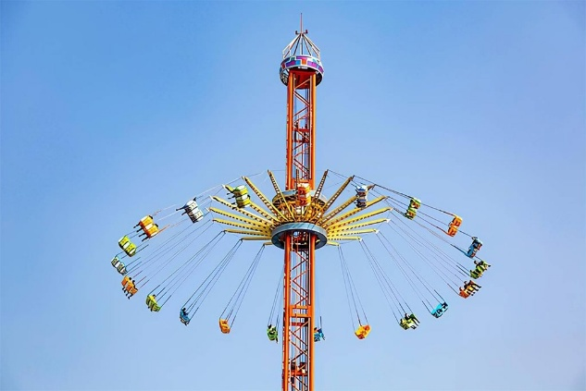
Inspired from the Amusement park ride “Sky Flyer”

3. User Journey
A visitor walks up to the exhibit and notices a miniature Sky Flyer ride enclosed within a glowing box. Curious, they scan the QR code and connect to the Mind Flayer network. A Stranger Things–themed page opens, guiding them with simple steps.
They press the button.
Inside the box, a laser beam comes alive, darting across mirrors in a precise path until it lands on the LDR sensor. The system is aligned. Suddenly, the Neo Pixel LEDs pulse in deep blues and purples, echoing the eerie energy of the Upside Down. A double beep follows — the ride is ready.
The lights fade. A quiet 20-second window begins.
The visitor raises their hand over the sensor. Instantly, the ride responds. As their hand moves up and down, the central rod follows, creating a sense of control — like they’re operating the ride itself. Meanwhile, the platform spins steadily, adding to the illusion.
As time runs out, soft beeps count down the final moments. The visitor lowers their hand, bringing the ride back to rest.
Then, everything stops. A final sound plays. The system resets, waiting silently for the next person to step in and take control.

4. Success Criteria
Functional
- The laser beam consistently reflects across all 6 mirrors and is accurately detected by the LDR.
- All indicator lights turn ON to confirm the system is powered and ready.
- The ultrasonic sensor provides stable distance readings.
- DC motor speed or activation changes correctly in response to the measured distance.
User Experience
- The system responds accurately to user input (no noticeable lag).
- User feels “in control” of the system, enabling intuitive and interactive engagement through responsive feedback.
Reliability
- The system runs continuously without random resets or failures.
- Sensor readings remain consistent under normal ambient conditions.
- Motors and outputs perform reliably across repeated use cycles.

5. System Overview
The user interacts with the model by moving their hand above an ultrasonic sensor. The sensor detects the hand height and sends that data to the ESP32. The ESP32 processes the reading and commands the motors to move the ride disk up or down to match the hand position. Simultaneously, LED strips light up and change color based on the sensor input, and a continuously spinning motor replicates the rotation of the ride.
-The main parts include:
ESP32 microcontroller, HC-SR04 ultrasonic, 2 DC motors via L298N, WS2812B RGB LED, Laser module and LDR sensor, Push button, Power supply adapters.

6. High-Level Block Diagram
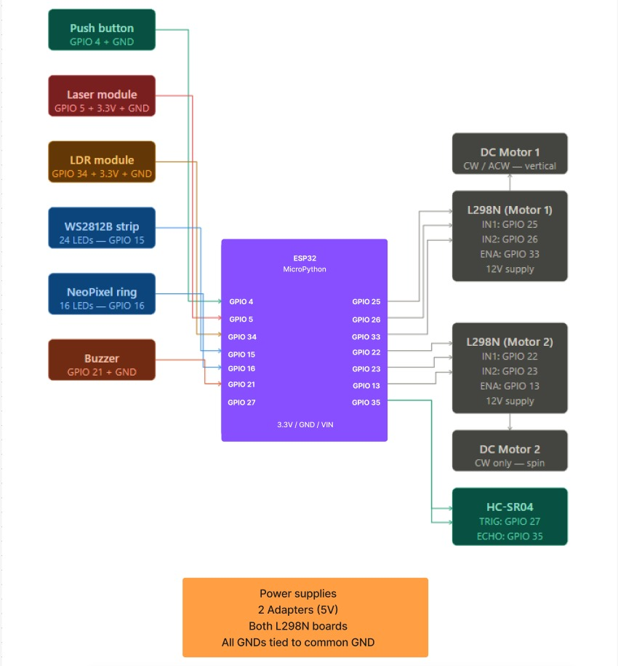

7. Input / Output Mapping
Input | Process | Output
- Ultrasonic sensor detects hand distance (2–30cm) | ESP32 maps distance to levels, smooths readings, applies 1 sec delay | DC motor 1 moves ride disk up or down.  DC motor 2 spins disk continuously at fixed speed
- Laser beam hits LDR sensor | ESP32 reads LDR value and checks for laser value | Lights turn on when beam is detected
- Push button pressed | ESP32 detects signal and triggers programmed event | Neo pixel and LEDs light up and ultrasound sensor starts detecting values
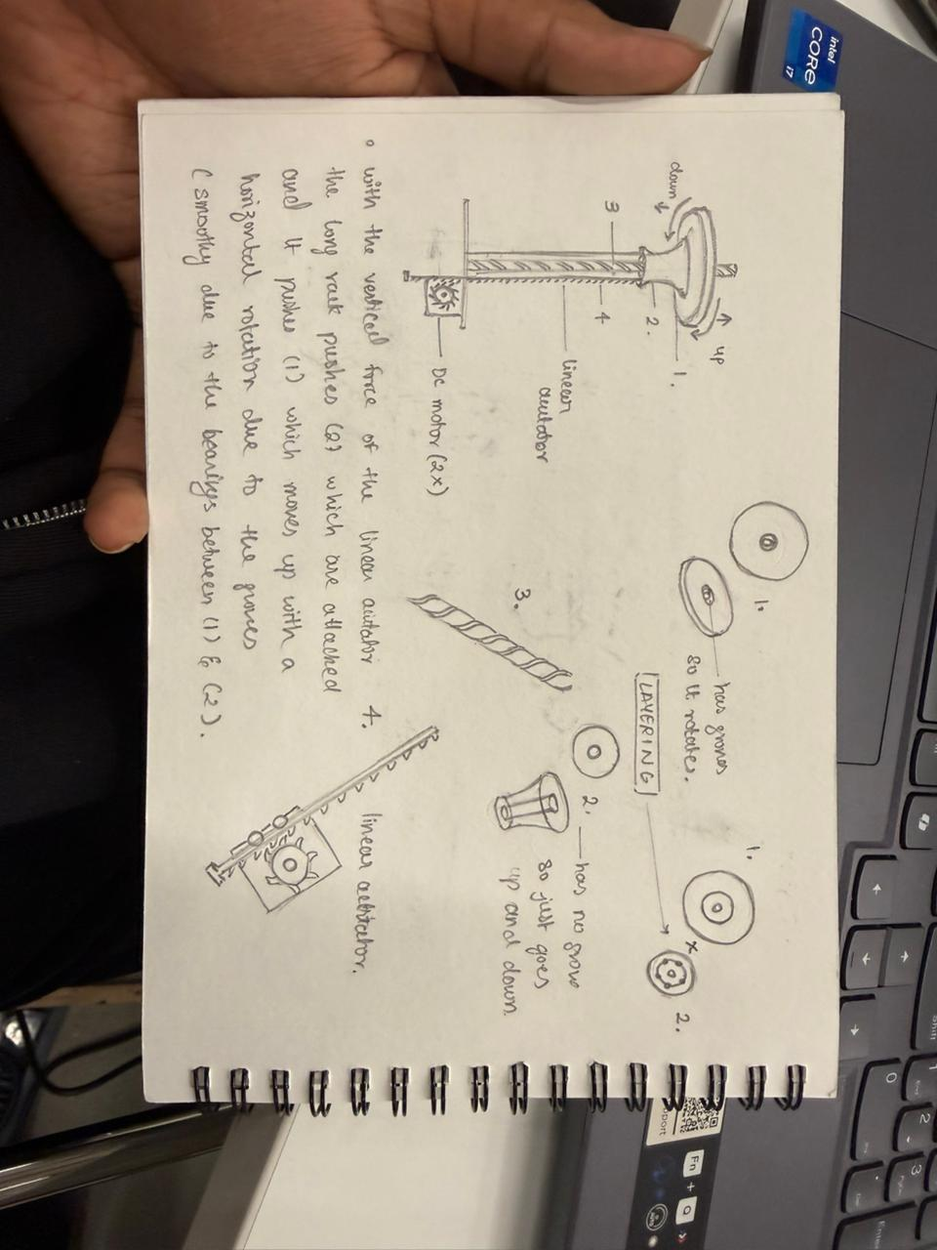

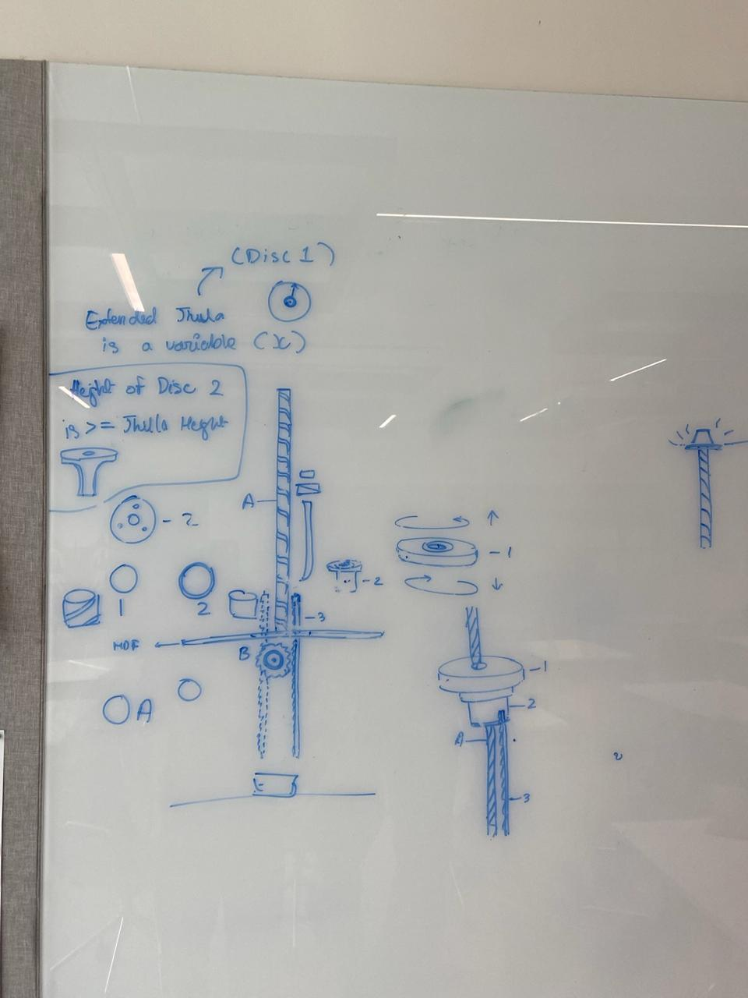
8. Sketches & Concepts
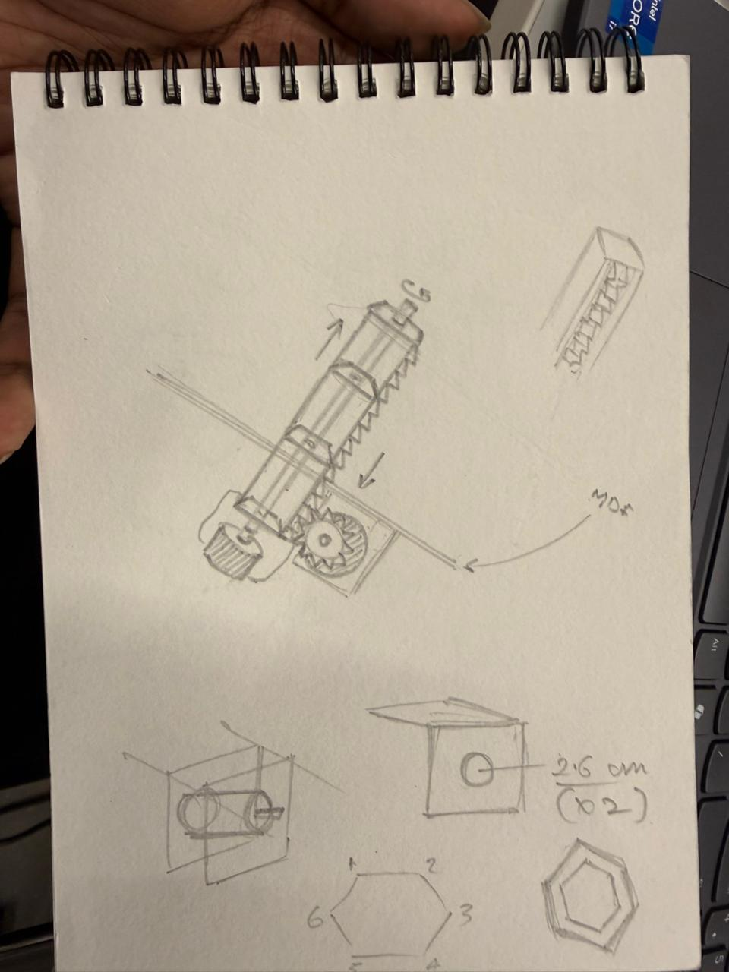

9.Final System Architecture (Labelled)
9.Final System Architecture (Labelled)

9.Final System Architecture (Labelled)

